Final Project – Sales Forecasting and Demand Prediction Analysis

Problem Statement :

Currently, the company is facing the following challenges:

Sudden increase or decrease in product demand
Poor sales planning
Inefficient inventory management

Objective:

The objective of this project is to understand how businesses
forecast future sales and customer demand using historical
Data.
End Results:

- Business insights:
Monthly and yearly sales trends:

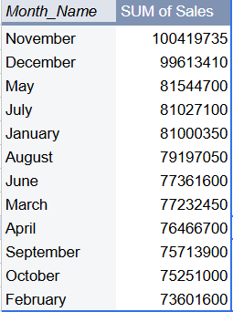
Product-wise sales performance:

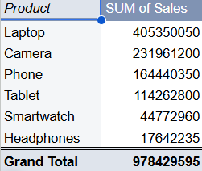

Seasonal demand patterns:
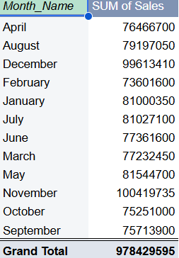

Growth or decline in sales over time:

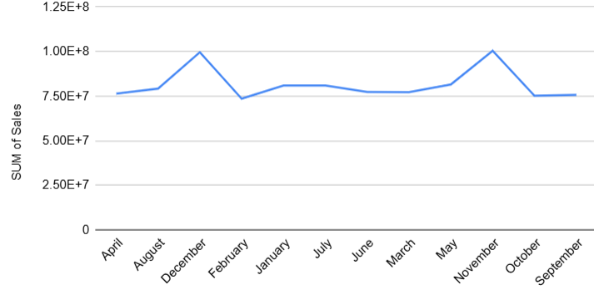

Dashboard:

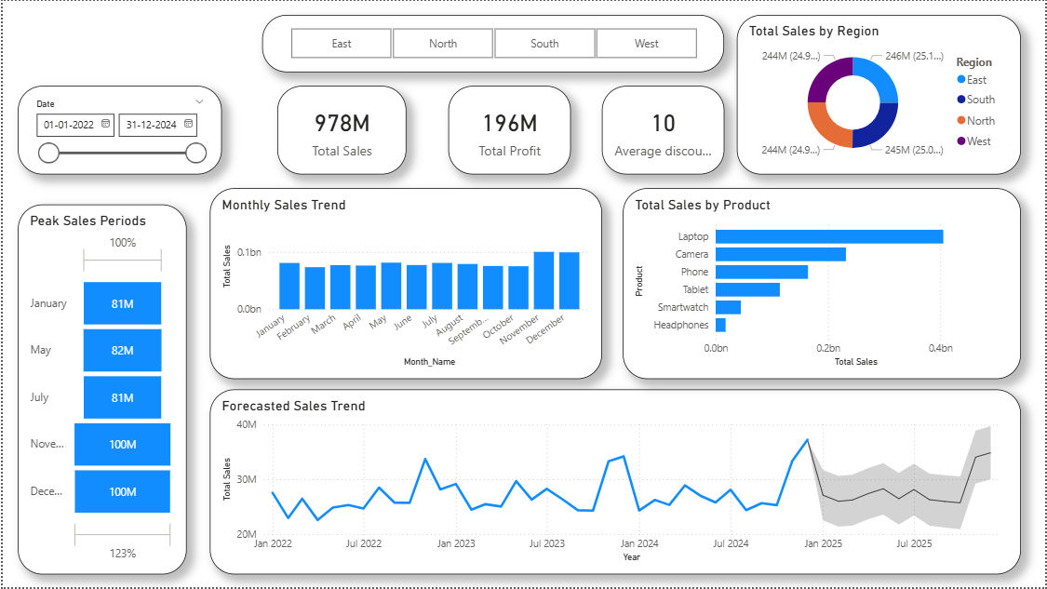

Questions Answered:
1. Which months have the highest sales?
November , December have the highest sales compared to other months.

2. Is there any seasonal pattern in sales?
The business exhibits strong seasonal trends, with peak demand during year-end months.

3. What is the overall sales trend (increasing or
decreasing)?
At the Year months(Nov-Dec) , there are highest sales where as Starting year months (Jan-Feb) , There are least sales.

4. Which products are expected to have high demand in
the future?
Laptop is the only product to have high demand as the larde no of laptops were sold over time.

5. How can the company improve demand planning?
By increasing the stock according to demand and sales in the particular time period , company should arrange stock accordingly.

Conclusion:
By this , the whole data was analyzed and turned into business insights , a dashboard is built to understand overall sales insights and done forecasting in the future time period to make the company overcome all their problems by following the tips accordingly.

